The European Green Deal and Green Transition

**I. Introduction**

Global warming is one of the major challenges faced by the world, which requires international cooperation and coordinated solutions to deal with. The European Union (EU) has declared its strong commitment to play a leading role in transitioning to a low-carbon economy. The European Green Deal is a comprehensive policy framework designed to reach the EU’s ambitious goal of reaching net-zero by 2050 and support the economy to transition to a more sustainable model and inclusive growth. The Deal has four pillars, which are carbon pricing, sustainable investment, industrial policy, and a just transition [(Claeys et al., 2019)](https://www.zotero.org/google-docs/?qFHd1w). This paper will first examine the effectiveness of the European Union Emission Trading System (EU ETS) and sustainable investment policies, which are instrumental in reducing greenhouse gas emissions and facilitating a green transformation. It will then explore the societal challenges precipitated by this green transition, including inequality and unemployment, underscoring the critical role of a just transition mechanism and policies focused on human welfare. Finally, the paper will delve into the energy crisis triggered by the Russia-Ukraine War and its effects on the EU’s green transition efforts.

**II. European Union Emission Trading System (EU ETS)**

The European Union Emission Trading System plays a crucial role in reducing carbon emissions and serves as a corestone of the EU’s efforts in combating climate change. According to the DIRECTIVE 2003/87/EC OF THE EUROPEAN PARLIAMENT AND OF THE COUNCIL (2003), the EU ETS is established for greenhouse gas emission allowance trading in order to promote reductions of greenhouse gas emissions in a cost-effective and economically efficient manner. [Sato et al.(2022)](https://www.zotero.org/google-docs/?vIYZ1b) argued that the system is considered as an environmental policy instead of tax policy, which is easier to be approved and aligns with the principle of “subsidiarity”, avoiding the concern of giving the EU fiscal powers arose in agreeing on a EU-wide carbon tax.

The EU ETS is a cap-and-trade system, “in which governments set an allowable total amount of emissions “cap” over a certain period and issue tradable emission permits” (The European Union Emissions Trading System Reduced CO2 Emissions despite Low Prices, n.d.). In theory, a cap-and trade system is more effective than imposing a carbon tax because it is a more flexible mechanism which not only ensures that the environmental objectives are achieved but also promotes economic efficiency by minimizing the overall cost of achieving these emission targets. With this carbon market, firms who can reduce emissions at lower costs are allowed to sell their extra allowances to those facing higher reduction costs, so the market’s aggregate cost of reducing emissions would be minimized. Additionally, emission trading would stimulate the development and deployment of green technologies by creating financial incentives for carbon reduction because firms would avoid purchasing allowance or paying for emissions, and lower emission levels would allow them to sell extra allowances to other firms to earn revenue and stay competitive.

However, in practice, the EU ETS faced several challenges, and it experienced four phases of reforms after coming into force in 2005. During Phase 1 (2005-2007), the allocation of European Union Allowances (EUA) was determined by each member state’s National Allocation Plan (NAP) using the method “grandfathering”. In other words, allowances were given for free in rough proportion to plants’ historical emission levels ([Sato et al, 2022](https://www.zotero.org/google-docs/?cAZ0tB)). This led to the moral hazard problem as firms might emit more in the short run in order to receive more allowances in the future. Due to lack of reliable data on emission levels, the NAP were made based on estimations, which led to the surplus of EUAs, causing the crash of its price. In 2007, the price of EUA plummeted to zero ([Sato et al, 2022](https://www.zotero.org/google-docs/?9uEwOV)). To address these issues, the second phase (2008-2012) aimed to tighten the cap on emissions, introduce some auctioning of allowances, and make better evaluations of NAPs with more accurate data. However, due to the 2008 financial crisis, which led to lower production levels, the allowance surplus problem persisted, and the price of EUAs remained low. This low price was problematic because it undermined firms' incentives to invest in green technologies because buying EUAs would be a more affordable option. In addition to the problem of oversupply, free allowance also caused the problem of windfall profits. Firms, especially in the electricity sector, raised the prices while receiving free allowances ([Sato et al, 2022](https://www.zotero.org/google-docs/?N7mQjk)), which harmed consumer welfare.

With the lessons learned in Phase 1 and Phase 2, the third phase (2013-2020) made some major reforms. First, auctioning became the default mechanism of allocation of EUAs, and the electricity sector was required to use 100% auctioning ([Sato et al, 2022](https://www.zotero.org/google-docs/?xNwEqG)). The shifts from free allowance to auctioning solved the problem of windfall profits because firms were required to pay for their emissions. Second, the Carbon Leakage Decision was established, where only carbon-intensive industries would be qualified getting free allowances, and instead of “grandfathering,” the allocation of EUAs was benchmarked based on the average performance of the 10% most efficient installations in a sector ([Sato et al, 2022](https://www.zotero.org/google-docs/?oQMDmb)). The method of “benchmarking”, in contrast to “grandfathering”, incentivised less efficient plants to improve their performance and reduce emissions to receive more free allowances, contributing to more green technology investments. Third, to address the critical issue of surplus of EUAs and price crashes, two mechanisms were introduced. Back-loading was a short-term solution, as it restricted the supply by postponing the sale of EUAs to auctions that would take place later ([Sato et al, 2022](https://www.zotero.org/google-docs/?f9el0k)), but this short-term solution did not solve the underlying problems. Therefore, the Market Stability Reserve (MSR) was introduced in 2019 as a long-term solution. Instead of selling back-loaded allowances in auctions, the MSR placed those allowances in reserve. Other than restricting supply, MSR played an important role in increasing the resilience of the EU ETS by addressing the imbalance of supply and demand during unexpected macroeconomic shocks and in stabilizing price. A stable price is important because it serves as a signal for green investment and carbon leakage. If the price is too low, firms would be less incentivized to invest in green technologies to reduce emissions because it would not be profitable. If the price is too high, industries with high carbon intensities would relocate to places with significantly lower emission prices than the EU, which undermined the global efforts in reducing greenhouse gas emissions.

The fourth phase (2021-2030) focuses on aligning the EU ETS with the EU's more ambitious climate targets for 2030 and restoring long-term price expectations. The emission cap was tightened at an annual linear reduction rate 1.74% - 2.2%, and the MSR was strengthened to more effectively tackle allowance surplus ([Sato et al, 2022](https://www.zotero.org/google-docs/?xtgdTP)). “Innovation Fund” and “Modernization Fund” were established to solve the concern that the costs associated with purchasing allowances or investing in emission reduction technologies would impact the global competitiveness of European industries. “Innovation Fund” supports the innovation of green technologies, using the revenues earned through auctioning 450 million allowances ([Sato et al, 2022](https://www.zotero.org/google-docs/?A58NL3)). These efforts not only lowered the threshold for green investment, but also helped lower the risk of carbon leakage. The “Modernisation Fund” supports EU member states with a GDP per capita below the EU average, in investments to modernize energy systems, improve energy efficiency, and foster energy transition, thus helping them to meet the EU ETS requirements more effectively. Regarding the free allowance allocation, an “output-based” methodology replaced “benchmarking,” allowing a more flexible and efficient allocation of free allowance for qualified sectors. Although the EU ETS has continuously adapted to meet its goal of reducing emissions while encouraging investments in green technologies through learning from previous shortcomings and experiencing several reforms, there are still some remaining challenges that should be addressed to enhance its effectiveness.

Carbon pricing within the EU ETS is intended not just as a regulatory measure but as a critical signal to the market, guiding investment decisions towards greener technologies. Despite the implementation of mechanisms such as the Market Stability Reserve (MSR) designed to mitigate market fluctuations, carbon prices within the EU ETS remain susceptible to significant volatility triggered by unexpected macroeconomic shocks and policy adjustments, which can hinder planned investments. Chevallier (2011)’s study on carbon pieces and macroeconomic and energy dynamics suggests that there is a robust relationship between carbon prices and macroeconomic environment, and [Fan et al. (2017)](https://www.zotero.org/google-docs/?3mYabW)’s study has shown that policy adjustments, especially those on supply and demand of EUAs, have significant impact on carbon prices. Given these insights, it is imperative to develop policies that effectively stabilize carbon price expectations in the face of macroeconomic fluctuations.

I propose that an enhanced monitoring mechanism for firms’ emissions levels should be instituted. Such a mechanism would ensure the provision of accurate and real-time data, which are essential for the EU to adjust the supply of EUAs responsively, mitigating the impact of economic downturns on carbon prices. This adjustment is crucial not only for stabilizing carbon prices but also for ensuring that these prices accurately reflect actual emissions, thereby enhancing the integrity and efficacy of the EU ETS. Stable expectations regarding carbon prices are critical in shaping investment strategies towards green technologies. Therefore, the EU should implement a regimen of regular announcements pertaining to adjustments in the supply of EU Allowances (EUAs). These announcements would serve as a signal to firms, indicating a probable increase in carbon prices, thus promoting enhanced investments in sustainable technologies. Furthermore, the application of fiscal and monetary policies aimed at stabilizing the macroeconomy can indirectly support the stability of carbon markets. For example, an increase in government spending would have expansionary effects on both aggregate demand and aggregate supply, restoring economic output to its potential level, which would help maintain a steady demand for carbon allowances. Such measures are essential for maintaining the efficacy and reliability of the carbon pricing mechanism within the EU ETS, particularly in the face of macroeconomic shocks.

Carbon leakage is another ongoing challenge. The free allowances were aimed to prevent carbon leakage, but due to problems such as oversupply and windfall profits, it was not the optimal way of addressing carbon leakage. In the European Green Deal, a Carbon Border Tax (CBT) was proposed, which in theory, should internalize the emission costs in the value chain: “putting a tax or tariff on the emissions embedded in imported products, and EU exporters might reclaim the cost of the emissions embedded in their products to ensure that European companies are not at a competitive disadvantage when selling abroad” [(Claeys et al., 2024)](https://www.zotero.org/google-docs/?RIYB25). However, in practice, it would be challenging to measure the emission content of imports, and the implementation of CBT would also face significant political challenges because of potential retaliation of trading partners and its conflicts with the WTO trading rules. Moreover, the extent of the carbon leakage problem is hard to measure, so it is debatable whether much political attention and effort should be paid in bringing CBT into force. [Claeys et al. (2024)](https://www.zotero.org/google-docs/?uFuLuF) argued that efforts and attention should still be prioritized on carbon price in Europe. To effectively address the challenge of carbon leakage, it is crucial to enhance support for carbon-intensive industries through subsidies aimed at fostering a transition to renewable energy. This strategy would not only assist these industries in becoming cleaner but also mitigate the impact of high carbon prices that might otherwise lead them to relocate their operations to regions with less stringent environmental regulations. By reducing the risk of carbon leakage in this manner, carbon prices can be stabilized at relatively higher levels within the EU ETS, thereby strengthening the incentive for emission reductions and encouraging greater investment in green technologies.

**Sustainable Investment**

Since there is a trade-off between reducing carbon emissions and real output level, to reach the net-zero target while maintaining the European economy’s competitiveness globally, it is important to decouple economic growth from natural resource consumption, which is the other main objective of the European Green Deal. Therefore, it is important to develop green technologies to achieve sustainable growth. But due to the uncertainties regarding innovation success, large amounts of money should be invested in research and development (R&D) to ensure a high probability of innovation success in the future, leading to a huge investment gap. The estimated green investment gap is at least €2.5 trillion for the 2021–2027 period (Making the European Green Deal Work for People, 2023), but [Claeys et al. (2019)](https://www.zotero.org/google-docs/?nmLKtk) argued that this value underestimates the total investments needed to finance the green transition to a green economy. Therefore, the EU should devise a strategic investment plan to fill this huge investment gap.

With a budget of €1 trillion, the EU alone is not enough to cover the huge investment gap, so it is important for the European Commission to encourage public investment in member states. This could be done through country-specific recommendations under the European Semester and the European fiscal framework should be reformed to be investment friendly and allow more flexibility of adapting to climate changes (Claeys et al., 2024). For example, the Stability and Growth Pact should be adjusted to exclude green investments from deficit calculations, thereby allowing higher spending on sustainable initiatives without breaching fiscal rules. Macroeconomic conditions should also be considered in reaching the goal of decoupling economic growth from natural resources consumption. The EU has been experiencing low interest rates, ranging from 0% to 0.55% from 2008-2022. Since adoption of green technology is capital-intensive, this historical low interest rates were favorable for public investment, especially on infrastructure. For example, Germany has taken advantage of this low interest rate to invest in energy-efficient buildings, and the KfW Bank offered reduced-interest loans to private households. However, the huge increase in investment would lead to a large shift of the “investment and saving” curve in the IS-LM model, leading to a higher interest rate and crowd out some investment. Therefore, the European Central Bank should cooperate to implement monetary policy to maintain a stable and relatively low interest rate to boost green investment.

Since private investment accounts for 17% of EU GDP, while public investment only accounts for 3% [(Claeys et al., 2019)](https://www.zotero.org/google-docs/?WXTtb6), private investment should also be mobilized. Although the EU ETS plays a role in incentivising green investments as illustrated in the previous sections, the EU cannot solely rely on it due to the volatility of carbon prices. Also, high carbon prices might lead to higher inflation, putting a threat on the overall European economy. Therefore, more effort should be paid, and the EU has taken several actions. The EU taxonomy, “a classification system that defines criteria for economic activities that are aligned with a net zero trajectory by 2050 and the broader environmental goals other than climate” [(*EU Taxonomy for Sustainable Activities - European Commission*, n.d.)](https://www.zotero.org/google-docs/?4Fomjq) was established in 2020 to direct investment to sustainable projects and economic activities. This system helps to incentivize private investment in green technologies in several ways. First, it increased the transparency in the market by obliging companies to provide detailed information about their sustainable activities. This increased transparency helped investors to make more informed decisions and boosts investors’ confidence. Second, the system encouraged innovation and stimulates R&D in markets that meet the taxonomy’s criteria.

Moreover, the EU has issued the European Green Bond (EuGB), and the green bond system played a significant role in the EU’s financing of the investment in sustainable projects. In 2021, the European Commission proposed a formal proposal of the European Union Green Bond framework under the European Green Deal, aimed to regulate the use of the designation EuGB, and the European green bond standard regulation was adopted in 2023. This regulation established a standardized framework designed to increase the consistency and comparability of green bonds within the market. By enhancing issuer credibility and boosting investor confidence, the framework seeks to ensure that funds raised through EuGB are directed towards projects that are verifiably aligned with the EU taxonomy for sustainable activities. Such alignment is critical in mitigating the risks of greenwashing, where projects are misleadingly presented as environmentally sustainable without substantive contributions to sustainability goals. Bhutta et al.’s (2022) research on the green bond’s development and effectiveness has shown that the green bonds market not only stimulated green investment but also contributed to economic growth, which aligns with the EU’s goal of transitioning to a green economy while sustaining economic growth.

Lastly, the European Investment Bank (EIB) would play an important role in financing the green transition. Claeys et al. (2024) suggests that the EIB financing should be dedicated to climate investment and target the green projects that are not covered by the national budget accurately. Along with the increase in funds, technical assistance activities should also be promoted to structure effective clean energy projects.

**IV. A Just Transition**

Achieving environmental goals set by the European Green Deal necessitates more than just technological and economic adjustments; it also demands a deep commitment to social justice to ensure the long-term success of the transition to a green economy. Thus, fostering an inclusive transition that leaves no one behind emerges as a critical objective of the Green Deal. However, policies necessary to reach the first two goals have some distributional consequences, hariming disadvantaged households and regions which increases inequality. Therefore, the EU and Member States should devise effective strategies in addressing these challenges to maintain social justice.

The first challenge is to manage the transition in coal and energy-intensive regions. Since coal is the main source of greenhouse gas emissions, the EU has decided to tackle and reduce domestic production of coal. However, coal plays an important role in the energy mix of some Member States and provides thousands of jobs. For example, Coal represents 80% in Poland’s power generation, and the coal industry in Poland employs half of the coal workforce, approximately 237,000 people (Hafner & Raimondi, 2020). Therefore, the EU’s climate policies that target at reducing coal production would cause severe unemployment problems in Poland, leading to their strong opposition to the EU’s climate-neutrality goal and their underperformance in reducing greenhouse gas emissions. Therefore, the EU should initiate effective policies in aiding these countries addressing the problem of raising unemployment to support their energy transitions. Claeys et al.(2024) suggests that the European Globalization Adjustment Fund (EGF), which used to support workers who lose their jobs because of major structural changes, could be extended to people who lose their jobs due to the decarbonization process in coal-mining regions. Amending the EGF would speed up the overall process by “avoiding the bureaucratic hurdles related to a new institutional set-up” (Claeys et al., 2024) and allocate the EU's budget most efficiently.

The second challenge is rising inequality. Climate change impacts and the transition to a green economy do not affect all groups equally. It will increase inequality both across nations and within nations. According to the World Bank (2023), regional economies with coal power plants and coal mines have lower GDP per capita than peers with a lower coal dependency. So the unemployment caused by the phase out of coal would make them further left behind and increase the income gap among Member States. Lower-income people would also bear more negative impacts within a country. For instance, policies such as Germany's phase-out of coal, which has traditionally been a more affordable source of electricity, result in higher electricity prices. This increase places a heavier economic burden on lower-income households and small industries, which typically have less financial flexibility to absorb higher costs or invest in energy efficiency. This rising inequality could lead to social unrest. A poignant example of this was seen in France in 2018 with the Yellow Vest Protests. These protests were ignited by a proposed increase in fuel taxes, which were part of France's efforts to reduce carbon emissions. Protestors contended that the increased fuel taxes would disproportionately affect rural and working-class citizens who have longer commutes.

Therefore, the European Commission and Member States’ national governments should cooperate to mitigate negative impacts post on disadvantaged groups. Claeys et al. (2024) argues that less regressive climate policies should be implemented to minimize distributional effects, such as putting high carbon prices on transportation sectors, especially on aviation instead of putting similar prices for heating and electricity. Moreover, the revenues gained from the EU ETS should be used effectively to compensate the regions and industries that are most affected by climate policies because a compensation mechanism is crucial for a public acceptance of climate policies and promotes social stability [(Claeys et al., 2024)](https://www.zotero.org/google-docs/?2ppo9u). This can be done through cash transfers. However, these policies would only have short-term effects.

On the micro level, disparities between skilled and unskilled workers will also be enlarged due to green transition, and this salary gap would exacerbate income and regional inequalities. According to the World Bank (2023), workers in green jobs, on average, have much higher skills than those in brown jobs, and as the green transition progresses, firms will demand more skilled workers to adapt to their changes into green technologies. The Human Transitions General Equilibrium Model (HTGEM) developed by the World Bank suggests that innovation success in green technology would lead to higher market concentration and regional inequality because companies who are at the innovation frontier of the market are usually the ones located in richer regions that have less dependence on carbon-intensive industries. Therefore, higher demand for skilled workers in richer regions would lead to higher wages, which increases the wage gap between skilled and unskilled workers. Moreover, technological innovation would also lead to higher productivity, thus, richer regions would experience higher economic growth rate, enlarging regional inequality.

To solve rising inequality from the roots, human development policies that focus on education and job retraining are crucial. According to the World Bank (2023), half of the skill gap between green jobs and brown jobs is explained by the difference between mean years of schooling. This highlights the necessity for enhanced educational policies that not only increase the mean years of schooling but also improve the quality of education to better prepare people for green jobs. Hence, Member States governments, especially those with lower than average GDP per capita, should put effort into reforming education policies. The reforms should shift education’s focus to students' foundational learning skills, which will enable them to succeed in a dynamic job market that requires them to continuously learn new skills. Higher education should also become accessible to a broader population and emphasize on research and development skills that are necessary for innovation of green technology that will help accelerate economic growth in poorer regions. Moreover, Member States governments should mobilize the Just Transition Funds to subsidize retraining programs and job matching, ensuring that they are accessible to workers in carbon-intensive industries, who are most at risk of job displacement due to the green transition. These programs will not only help workers gain new skills and adapt to the transition from brown jobs to green jobs, but also reduce frictional unemployment.

Hence, with human development policies, the unintended adverse consequences of the green transition, such as growing inequality and unemployment could be effectively tackled, and a better educated and more skilled labor force can also bring broader positive effects on overall economic development.

**V. The Energy Crisis**

The EU has a high dependence on the imports of natural gas from Russia, a fossil fuel energy source that has lower CO2 emissions compared to others. After Russia’s invasion of Ukraine, the EU’s sanctions against Russia have been phasing out oil and gas imports from Russia, sources that played a critical role in the EU’s energy mix. This shortfall in supply led to natural gas prices’ increase to seven times compared to early 2021 in Europe (see Figure.1), and triggered the EU’s energy crisis. Since the energy sector is the largest contributor to the greenhouse gas emissions in the EU, accounting for 28% of total emissions, it is worthwhile to dissect the effects of the energy crisis on the EU’s green transition. In this section, I will first discuss the energy crisis’s effects on the EU’s macroeconomic condition. Then, I will analyze its impact on the EU’s green transition through its effects on the EU ETS, investments in renewable energy, and the just transition mechanism.

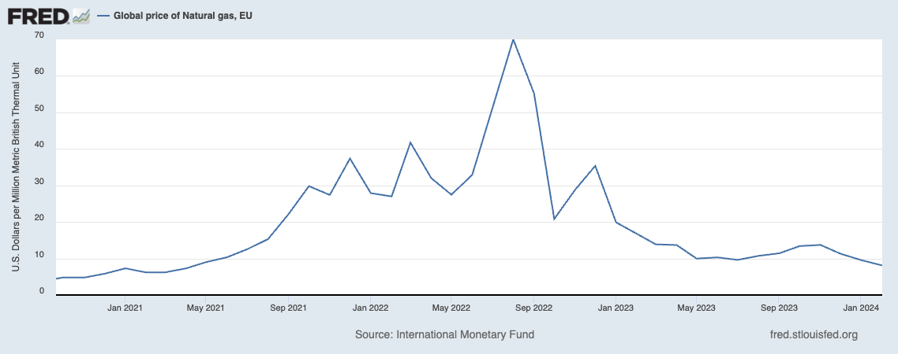

Figure.1

**V.1 Effects On Macroeconomic Condition**

Natural Gas is one of the primary sources of energy for both electricity generation and heating in many EU countries because it is cleaner than other fossil fuels, such as coal and crude oil. Therefore, the drastic increase in natural gas price led to a huge increase in electricity and heating cost, which fueled inflation in the EU because they are a substantial part of households’ cost of living, and they increased cost of overall production, for which businesses often pass onto consumers in the form of increased prices for goods and services. Figure.2 shows the trend of natural gas prices, electricity price, and inflation rate. It is clear that after the invasion of Ukraine by Russia in 2022, all of the three indices increased sharply.

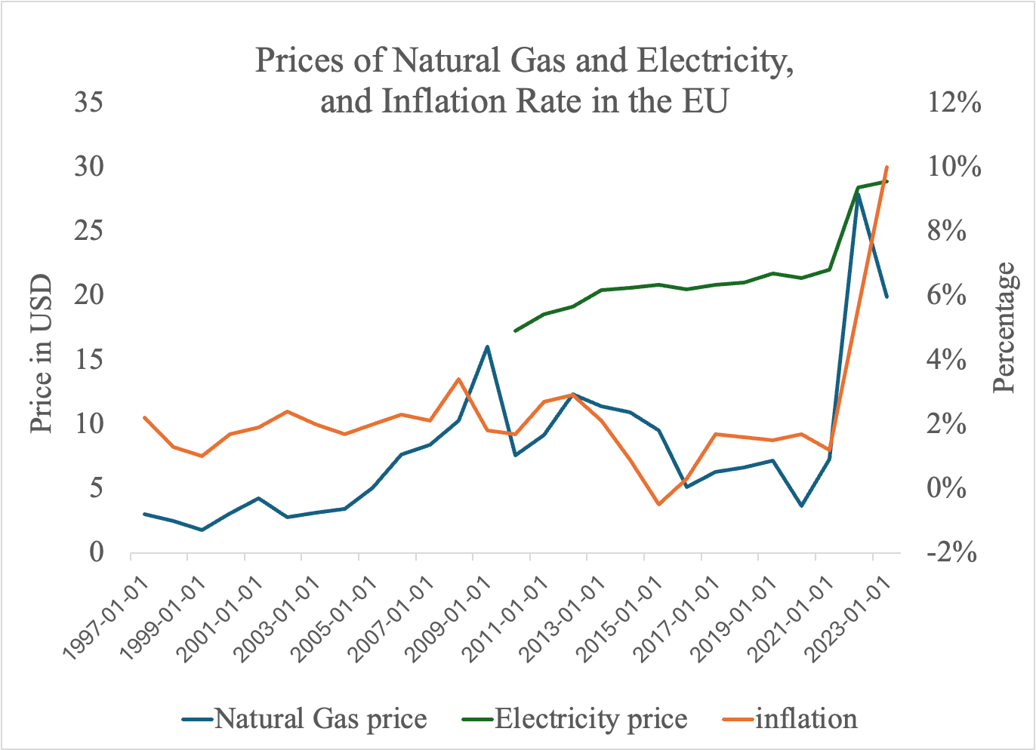

Figure.2

Although the natural gas prices started to fall in the beginning of 2023, the electricity prices and inflation maintained their increasing trend, especially inflation. This is because inflation is largely impacted by people’s expected inflation. Since both producers and consumers would expect high natural gas prices, they would expect prices to be high, resulting in an actual high inflation. This high inflation would worsen the European economy in several ways. First, some small businesses had not recovered from the economic downturn caused by the outbreak of COVID-19 pandemic, and were already in need of subsidies. The increase in energy prices put further pressure on their economic burden, which led to their lower production level. Second, the high inflation rate led to a large decrease in consumer’s real purchasing power and their real wages, so their real consumption would go down, shrinking the aggregate demand. Both the shocks on supply and demand led to a decreased economic growth rate in the EU. Real GDP growth rate decreased by 2.6% between 2022 and 2023 (see Figure.3).

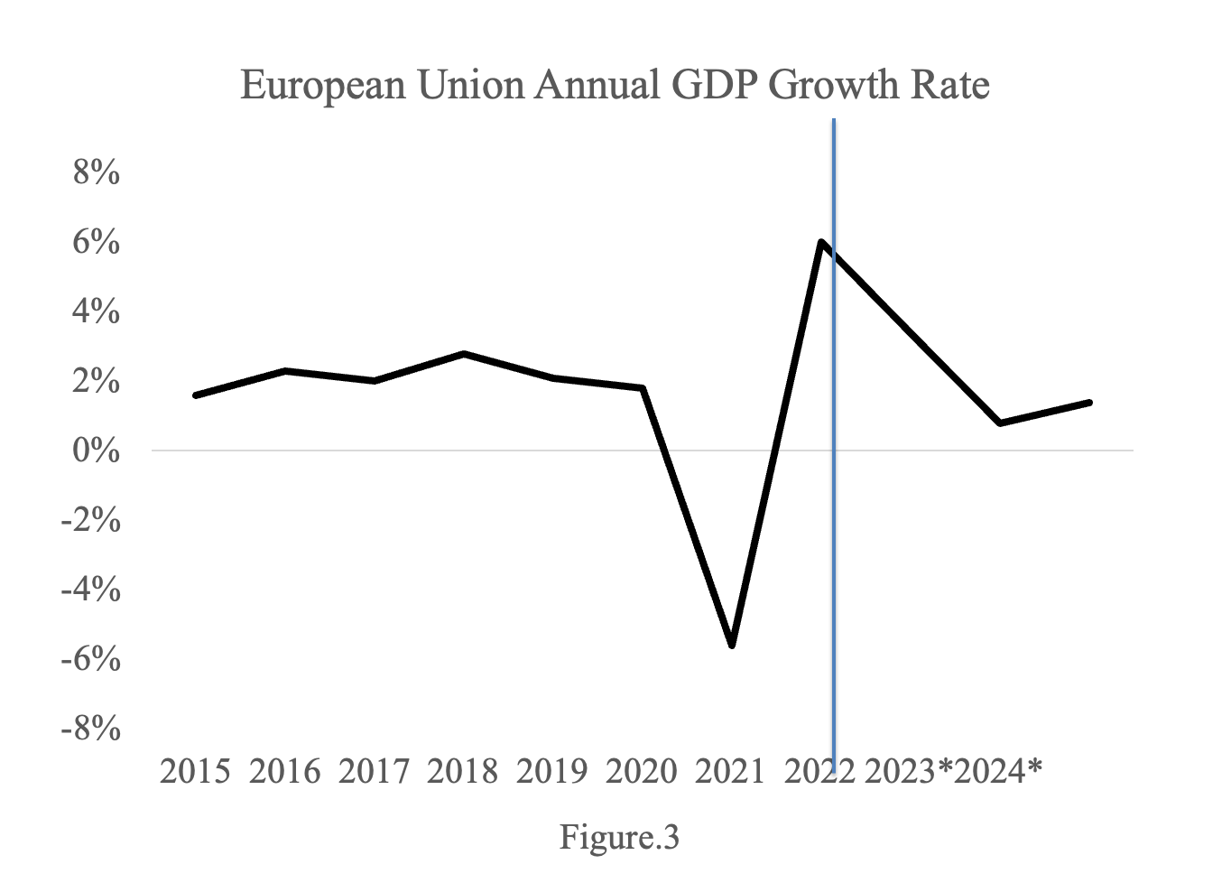

The simultaneous occurrence of inflation and decreased economic growth rate would lead to the concern of stagflation, which complicated the policy responses of both monetary policy and fiscal policy. During stagflation, the central bank and government would face policy tradeoffs. If the policymakers decide to increase aggregate demand, it will cause further inflation, if the policymakers hold aggregate demand constant, then the unemployment rate will remain high in a certain period, and fall in the long run. Therefore, it is hard for policymakers to make a choice between a higher inflation or a fluctuating economy. In response to the energy crisis, the EU Member States governments have introduced subsidies and price caps to shield consumers and businesses from the worst impacts of the energy price rises. These measures were designed to prevent a more severe economic downturn. This increase in government spending led to a higher aggregate demand, but at the risk of higher inflation. Therefore, the European Central Bank (ECB) had made the decision to raise interest rates in order to combat inflation. The key interest rates were continuously set higher from 2022, increasing from 0.55 in July, 2022 to 4.5% in September, 2023. Nevertheless, this increased interest rate might lead to a decrease in investments, which would have a potential negative impact on economic growth. The interplay of monetary and fiscal policy turned out to be effective in solving the policy dilemma of stagflation. Member States’ fiscal policies helped to restore output, while the ECB’s monetary policy tackled inflation. As we can see in Figure.3 the economic growth rate started to increase again in 2024, indicating that the policies were effective.

Moreover, inflation would also have a negative impact on the EU’s socio-economic condition because it would exacerbate the problem of poverty and inequality. The increase in energy prices hit low-income households more because they spend a larger share of their income on energy and essential goods. It also hit them disproportionately across EU countries. Northern and Western European countries are richer compared to Central and South Eastern European countries. Low-income households in the richer regions are more likely to absorb the increase in energy prices as they have more savings. On top of that, Central and Eastern European countries are more dependent on oil and gas imports from Russia and have less resources of renewable energy. So, they experienced a more severe energy shock. According to the European Investment Bank (2022), energy imported from Ukraine, Russia, and Belarus accounted for 90% of Estonia’s energy imports and 98.7% of Lithuania’s energy imports. Therefore, regional inequality would be enlarged due to the energy crisis.

**V.2 Effects on the Green Transition**

To dissect the effects of the energy crisis on the green transition, it is important to first look at how it affects the European Union Emission Trading System (EU ETS) because it plays a crucial role in both regulating total emissions and also incentivising investment in sustainable projects. After Russia's invasion of Ukraines in February in 2022, the EUA prices fell dramatically. In March, 2022, the price reached its lowest point of 58.3 euro/tonne, which was a 37% fall compared to its level prior to the invasion (see Figure.4). This dramatic decrease in the EUA price might be caused by an increase in supply of the allowances in the market. Since many firms were hurt by the increase of natural gas and electricity prices, to compensate for their losses caused by this increase, they would sell their unused emission allowances. This exogenous shock on the supply drove down the price of EUAs. But after reaching its lowest point, the price started to rebound and returned to a high value in August, 2022 because demand for emission allowance increased. This was due to European countries' reactivation of their coal-fired or oil-fired power plants to compensate for the energy gap caused by the huge shock on natural gas supply (Liu et al., 2023).

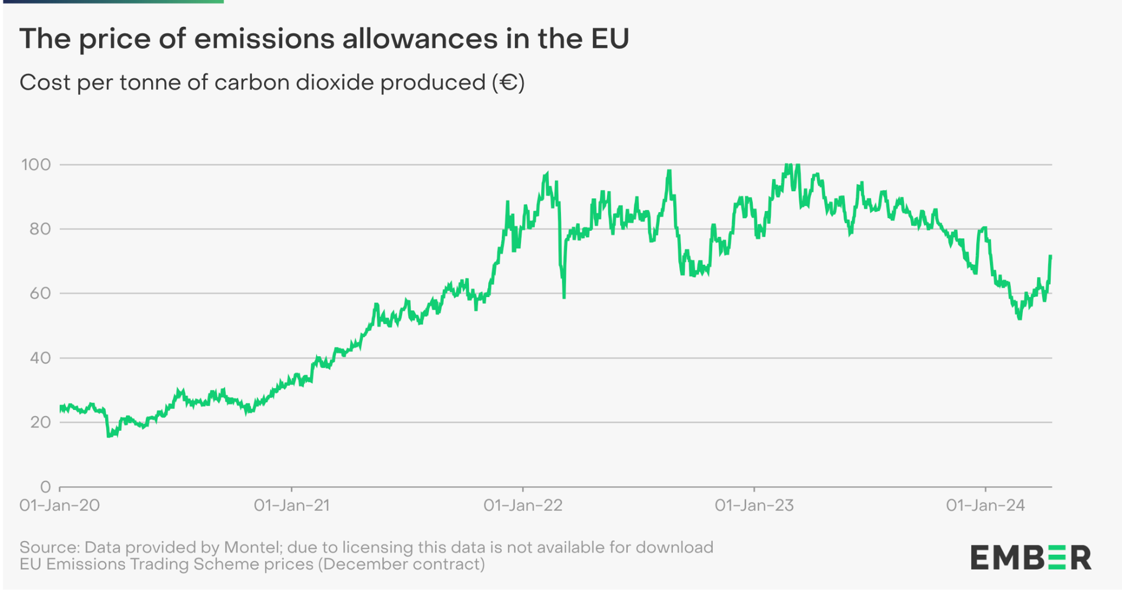

Figure.4

Additionally, the EUA price experienced high volatility between 2022 and 2024, and this volatile price would impact the green transition negatively as illustrated in section 2 of the paper. After 2023, the EUA prices started to decrease again, and this decrease aligned with the decrease in natural gas prices (see Figure. 1), which indicated that the decrease in EUA prices was possibly led by the decrease in demand for emission allowance because firms change back to natural gas as the source of energy. Other factors also contributed to this decrease in price. First, between 2023 and 2024, GDP growth rate was decreasing, indicating a reduced economic activities, and, thus, lead to less demand for emissions. Second, the REPowerEU plan was implemented in May, 2022, aimed at reducing the EU’s dependence on Russian fossil fuels and accelerate the green transition, by saving energy, investing in renewables and diversifying energy supplies [(*The REPowerEU Plan Explained*, n.d.)](https://www.zotero.org/google-docs/?DnofKz). The diversification of energy mix and more investment in renewable energy infrastructures led to a reduced demand for emission allowance. Additionally, this plan was financed by selling EUA allowances, which led to an increase in supply in the emission trading market. So, the decrease in demand and increased supply together drove the EUA price down.

Although a more diversified energy mix and lower dependence on imported energy is beneficial to both the EU’s green transition and energy security, the low EUA price may lead to some potential problems. As illustrated in section II of the paper, the Innovation Fund and the Modernisation Fund was financed by the revenue earned through auctioning EUAs. So a low EUA price would lead to less revenues of Member States governments. Therefore, there would be less financial support for innovation in the long run.

The effects of the energy crisis on sustainable investment is ambiguous. Given the macroeconomic condition with a higher interest rate combined with a high inflation, investment incentive and ability would be undermined. Higher interest rates increase the cost of borrowing, which can discourage private investment in sustainable projects because they are usually capital-intensive. Additionally, in a high inflation environment, investors might shift their focus away from risky projects with long payback periods, so they would invest less in green technology because there is a high uncertainty of innovation success. However, the adverse impact on macroeconomic conditions shows an urgent need to enhance energy independence. Therefore, state governments employed a range of policy instruments to foster the development and use of renewable energy sources in order to ensure energy security and reduce the impact of external energy shocks. This facilitated the public investment in green transition.

Lastly, the potential enlarged regional inequality will impede the EU’s efforts of fostering a just and inclusive transition. Central and Eastern Europe have more dependence on natural gas and oil imports from Russia, leading to their higher energy vulnerability. This high dependency also implies that they have less diversified energy mix and require more investment in renewable energy projects and infrastructure for the green transition. However, these regions were hit most by the energy crisis as illustrated in section V.1. To maintain the macroeconomic conditions, more government budgets would be reallocated to address short-term energy needs, such as subsidizing energy costs for consumers and businesses. This reallocation can divert funds away from planned investments in green technologies and projects, exacerbating the green transition gap. Therefore, the EU should focus more on the use of the Just Transition Funds to effectively support the vulnerable regions. Moreover, this rising inequality emphasizes the importance of human development policies to prevent these regions from falling behind. Investment in local education and job training can help these vulnerable areas overcome structural disadvantages and integrate more fully into the broader EU green transition, which will enhance the overall resilience and equity of the green transition process, ensuring that no community is left behind as Europe moves towards a greener future.

**VI. Conclusion**

The EU's commitment to achieving net-zero emissions by 2050 through the European Green Deal is a testament to its leadership in global efforts to combat climate change. This paper has examined the European Union Emission Trading System (EU ETS) and sustainable investment policies as crucial mechanisms driving the reduction of greenhouse gas emissions and green investment. It has also highlighted the societal challenges that accompany this transition, such as inequality and unemployment, and emphasized the importance of just transition mechanisms and human development policies.

The EU ETS has proven to be a dynamic tool in managing carbon emissions, with its cap-and-trade system encouraging economic efficiency and technological innovation. However, it has faced challenges such as price volatility and the need for continuous adaptation to achieve its goals effectively. Sustainable investment, on the other hand, remains critical in closing the green investment gap. Both public and private investments are essential, with innovative financial instruments and policy adjustments needed to mobilize resources effectively under fluctuating macroeconomic conditions.

The energy crisis triggered by the Russia-Ukraine War introduced additional complexities, affecting the EU's macroeconomic stability and its green transition trajectory. This crisis has underscored the fragility of dependency on external energy sources and highlighted the urgent need for energy diversification and increased investments in renewable energy. Moving forward, the EU must continue to refine and strengthen the mechanisms of the EU ETS, enhancing its stability and predictability. Policies aimed at ensuring a just transition, focusing on supporting the most affected regions and communities through targeted funds, educational programs, and job retraining initiatives must also be prioritized to ensure the principles of inclusivity, sustainability, and resilience.

References

[Chevallier, J. (2011). A model of carbon price interactions with macroeconomic and energy dynamics. *Energy Economics*, *33*(6), 1295–1312.](https://www.zotero.org/google-docs/?broken=yAnsdp) <https://doi.org/10.1016/j.eneco.2011.07.012>

[Claeys, G., Tagliapietra, S., & Zachmann, G. (2024). *How to make the European Green Deal work*.](https://www.zotero.org/google-docs/?q8P57G)

[*EU taxonomy for sustainable activities—European Commission*. (n.d.). Retrieved April 15, 2024, from https://finance.ec.europa.eu/sustainable-finance/tools-and-standards/eu-taxonomy-sustainable-activities_en](https://www.zotero.org/google-docs/?q8P57G)

[Fan, Y., Jia, J.-J., Wang, X., & Xu, J.-H. (2017). What policy adjustments in the EU ETS truly affected the carbon prices? *Energy Policy*, *103*, 145–164. https://doi.org/10.1016/j.enpol.2017.01.008](https://www.zotero.org/google-docs/?q8P57G)

[Kuzemko, C., Blondeel, M., Dupont, C., & Brisbois, M. C. (2022). Russia’s war on Ukraine, European energy policy responses & implications for sustainable transformations. *Energy Research & Social Science*, *93*, 102842. https://doi.org/10.1016/j.erss.2022.102842](https://www.zotero.org/google-docs/?broken=qxG4BK)

[Liu, Y., Xie, X., & Wang, M. (2023). Energy structure and carbon emission: Analysis against the background of the current energy crisis in the EU. *Energy*, *280*, 128129. https://doi.org/10.1016/j.energy.2023.128129](https://www.zotero.org/google-docs/?broken=xos86Y)

[*Net-Zero Industry Act—European Commission*. (n.d.). Retrieved March 31, 2024, from](https://www.zotero.org/google-docs/?broken=2TBm9o) <https://commission.europa.eu/strategy-and-policy/priorities-2019-2024/european-green->

[Sato, M., Rafaty, R., Calel, R., & Grubb, M. (2022). Allocation, allocation, allocation! The political economy of the development of the European Union Emissions Trading System. *WIREs Climate Change*, *13*(5), e796.](https://www.zotero.org/google-docs/?broken=SVvSpO) <https://doi.org/10.1002/wcc.796>

[*The REPowerEU plan explained*. (n.d.). Retrieved April 16, 2024, from](https://www.zotero.org/google-docs/?q8P57G) <https://www.consilium.europa.eu/en/infographics/repowereu/>

[*The European Union Emissions Trading System reduced CO2 emissions despite low prices*. (n.d.). https://doi.org/10.1073/pnas.1918128117](https://www.zotero.org/google-docs/?broken=55Xmcz)

[*The Green Deal Industrial Plan—European Commission*. (n.d.). Retrieved March 31, 2024, from https://commission.europa.eu/strategy-and-policy/priorities-2019-2024/european-green-deal/green-deal-industrial-plan_en](https://www.zotero.org/google-docs/?broken=kHfxWM)

[*Ukraine conflict threatens Europe’s recovery and mass poverty*. (n.d.). European Investment Bank. Retrieved April 16, 2024, from https://www.eib.org/en/stories/ukraine-trade-inflation](https://www.zotero.org/google-docs/?q8P57G)